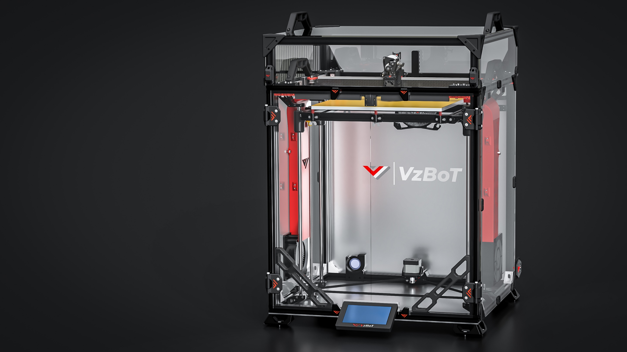

# About

This manual is intended for the aluminum parts for VZ330 as sold by F3D-Racing and Mellow. The aluminum parts are interchangeable with the printed parts, some additional hardware is required when purchasing the motor mounts and idler mounts. Furthermore some printed parts are required in order to mount your new sexy parts!

Beware, VZ330 was never designed around AWD like VZ235. Because of this the design team was left with the frame as constraint. Due to which it was not possible to have a design that did not limit y travel for the VZ330 printhead. There is a 10mm loss in Y travel coming from 330mm.

<https://f3d-racing-fdm.myshopify.com/collections/vzbot-vz330>

<https://mellow.nl.aliexpress.com/store/1531088?spm=a2g0o.detail.1000007.1.67f7726dJRpvIK\>

*Disclaimer: VzBoT is an opensource passion project, this manual is not definitive, and we try to make it as polished as possible. Fortunately, we all make errors so use common sense when following this guide.

# Print settings:

We recommend printing all parts in ABS, ASA or similar material to be able to withstand the high heat environment in the printer enclosure.

Print settings should always be tuned for your own material and tested for decent strength and layer adhesion.

We recommend the following settings:

***For non-moving parts:***

Layer height: **0.2mm**

Layer with: **0.4 to 0.6 mm**

Number of walls: **4**

Infill percentage: **40 to 50 %**

Top/bottom layers: **5**

***For moving parts:***

Layer height: **0.2mm**

Layer with: **0.4 to 0.6 mm**

Number of walls: **4**

Infill percentage: **30 to 40 % depending on your material**

Top/bottom layers: **5**

# AWD Motormounts/Idlers

## Bom:

|  |  |  |
| --- | --- | --- |
| Material | Quantity | Notes |
| M3 30mm | 2 |  |
| M3 6mm | 6 |  |
| M4 10mm | 10 | +2 for mellow version |
| M4 T-nut | 10 |  |
| Shoulder bolt 5mmx20mm [M3] | 4 | M3 threading with 6mm of threaded length, if longer grind down the ends. Correct shoulder bolts available at mellow & F3D |
| GT2 Toothed idler | 2 |  |
| Gt2 Smooth idler | 2 |  |
| GT2 motor pulley | 2 |  |

## STL files:

|  |  |
| --- | --- |
| File name | Amount to print |
| Spacer long | 4 |
| Spacer short bottom | 2 |
| Spacer short top | 2 |
| Spacer M3 corner | 2 |

## Step 1:

Mount the GT2 drive pulley to the motor and attach the motor to the bottom plate using 6mm M3 screws.

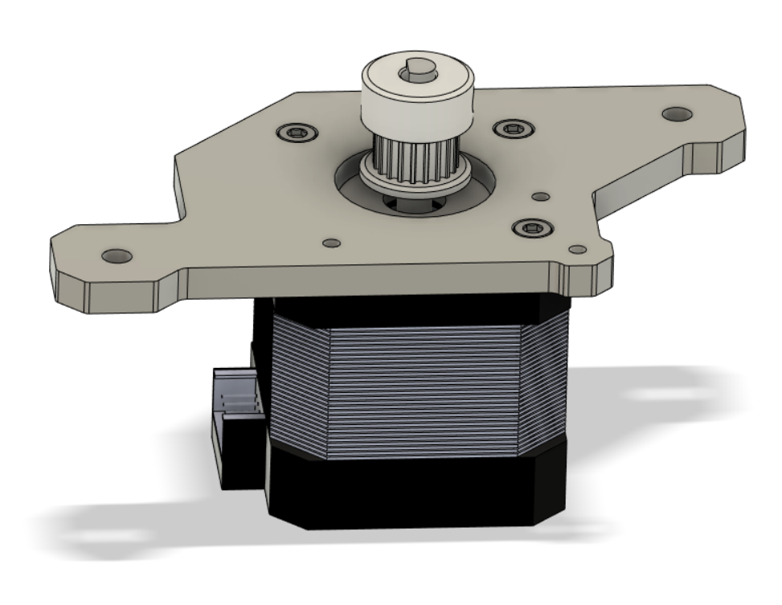

## Step 2:

Mount the 10mm M4 nuts and t-nuts to the top plate. Then put the shoulder bolts in place in the top plate and push on the printed spacers and idlers like shown below, making sure they are in their right position. The printed spacers are tight enough to where this assembly (with some care) will stay together.

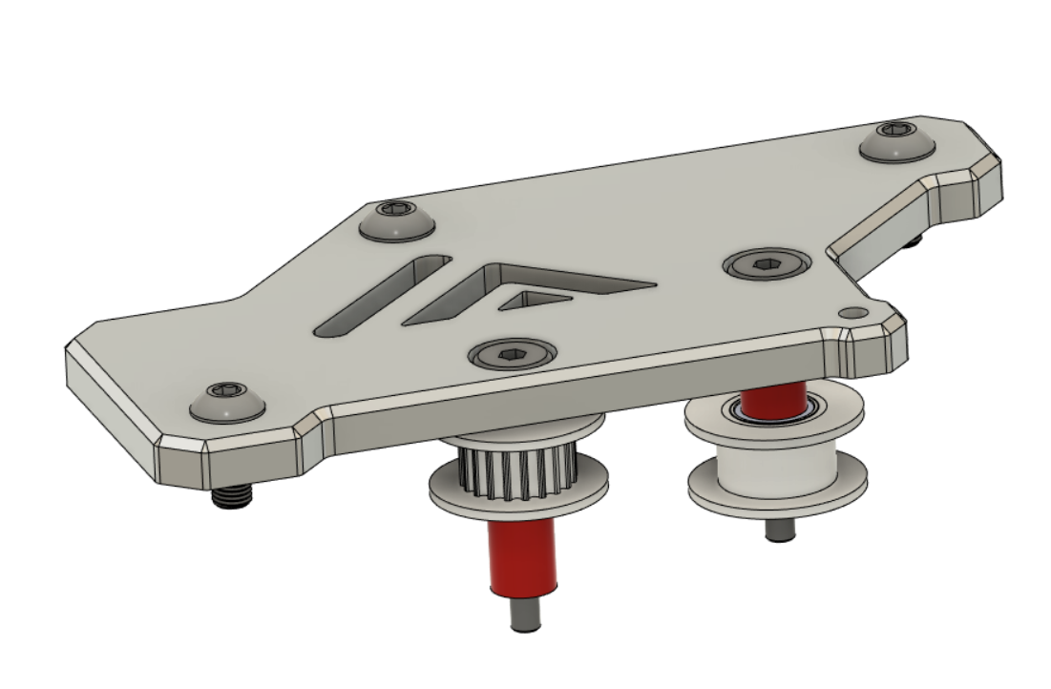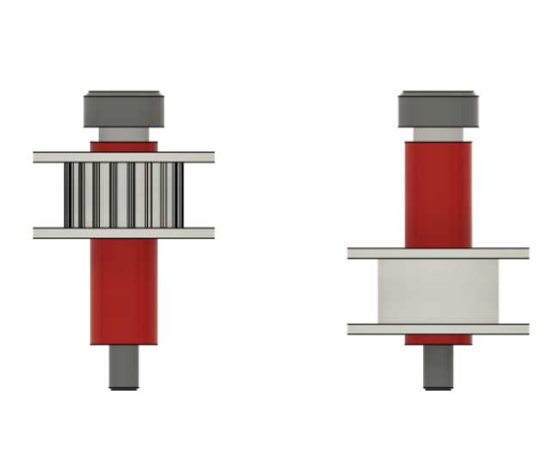

## Step 3:

Attach the bottom assembly to the printer frame using 10mm M4 screws and t-nuts. After this attach the top assembly from the previous step loosely. Make sure the shoulder bolts thread before tightening all screws.

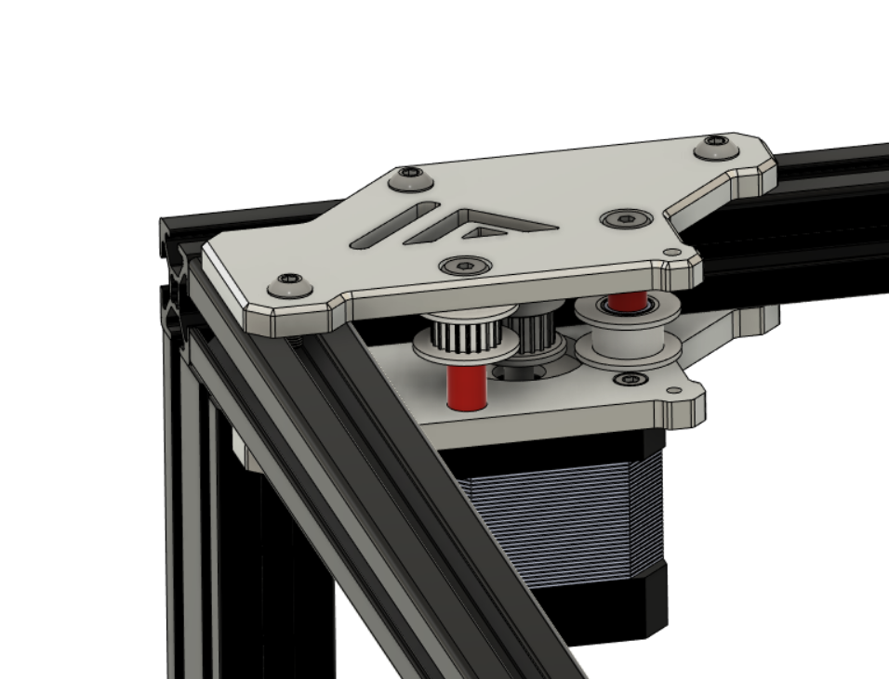

## Step 4:

Insert the printed corner spacer and install the 30mm M3 like shown below.

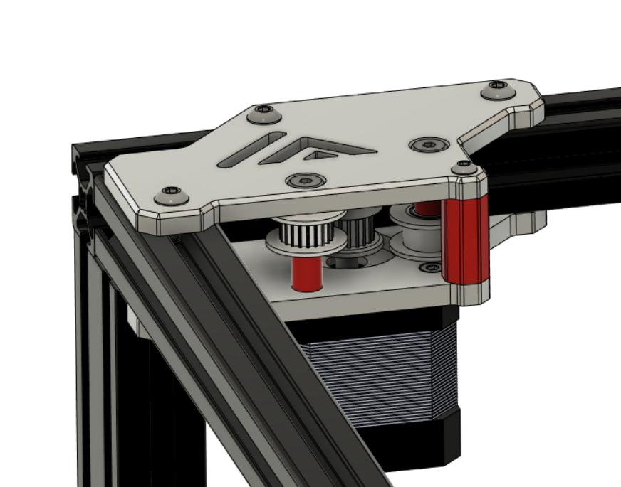

## Step 5:

Repeat the same process for the other side making sure to put the idlers in their correct position.

# Firmware:

Klipper, RRF and Marlin natively support AWD for Corexy kinematics. For a Klipper example Cfg suited for AWD check the VZ235 Github page.

<https://github.com/VzBoT3D/VzBoT-Vz235/tree/main/Firmware>

## XY motion Example CFG Klipper:

[stepper_y]

step_pin: PE11

dir_pin: !PE10

enable_pin: !PE9

rotation_distance: 40

microsteps: 16

full_steps_per_rotation: 200

endstop_pin: ^PB13

position_endstop: 0

position_max: 235

homing_speed: 25

homing_retract_dist: 0

[tmc5160 stepper_y]

spi_bus: spi4

cs_pin: PE7

interpolate: false

#diag1_pin: PB14

run_current: 1.6

[stepper_y1]

dir_pin: !PC13

enable_pin: !PE5

step_pin: PE6

rotation_distance: 40

microsteps: 16

full_steps_per_rotation: 200

[tmc5160 stepper_y1]

spi_bus: spi4

cs_pin: PC14

interpolate: false

#diag1_pin: PB14

run_current: 1.6

[stepper_x]

step_pin: PD8

dir_pin: !PB12

enable_pin: !PD9

rotation_distance: 40

microsteps: 16

full_steps_per_rotation: 200

endstop_pin: ^PB14

position_endstop: 0

position_max: 235

homing_speed: 25

homing_retract_dist: 0

[tmc5160 stepper_x]

spi_bus: spi4

cs_pin: PE15

#diag1_pin: PB13

interpolate: false

run_current: 1.6

[stepper_x1]

dir_pin: !PE4

enable_pin: !PE3

step_pin: PE2

rotation_distance: 40

microsteps: 16

full_steps_per_rotation: 200

[tmc5160 stepper_x1]

spi_bus: spi4

cs_pin: PC15

interpolate: false

#diag1_pin: PB14

run_current: 1.6

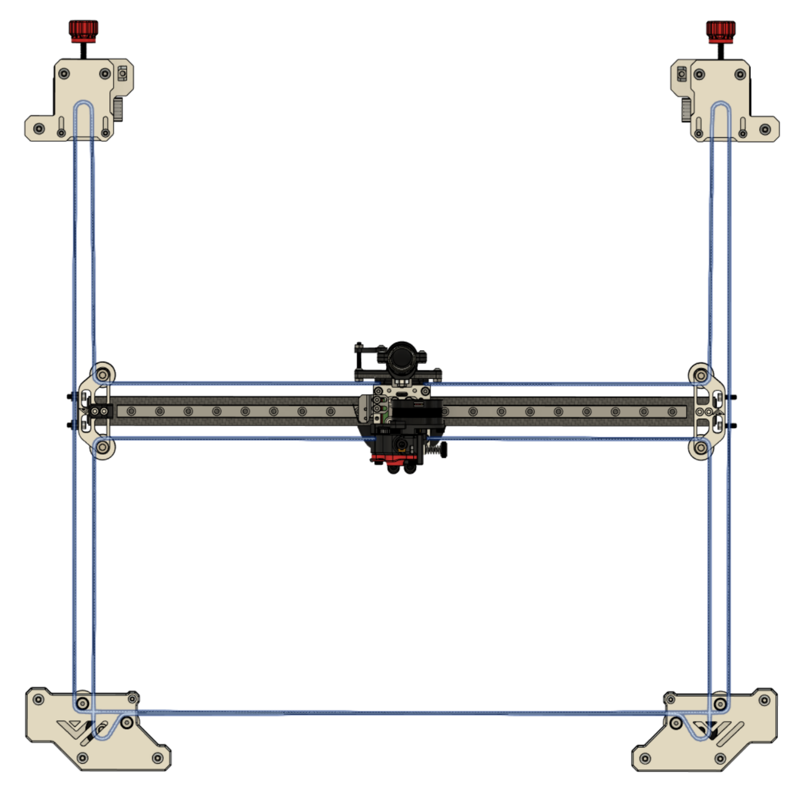

# Setup and tuning:

After finishing the build one must take care to properly set up the AWD system. It is important to “sync the motors”. In order to achieve this it is advised to use the following macro’s in klipper:

[gcode_macro enable_stepper]

gcode:

SET_STEPPER_ENABLE STEPPER=stepper_x ENABLE=1

SET_STEPPER_ENABLE STEPPER=stepper_x1 ENABLE=1

SET_STEPPER_ENABLE STEPPER=stepper_y ENABLE=1

SET_STEPPER_ENABLE STEPPER=stepper_y1 ENABLE=1

[gcode_macro disable-steppers]

gcode:

m84

## Step 1:

Set belt tension like on a normal 2WD VZ330.

## Step 2:

Loosen the grubscrews on one of each set of motors, make sure the grub screws will not be on the flat side of the stepper shaft.

## Step 3:

Boot up the printer and order “enable stepper”.

## Step 4:

Tighten the stepper grub screws and disable steppers again.

***Designed and developed by:***

*The VzBot Team*

 <https://discord.gg/qmMeD6Vt3W>



<https://www.facebook.com/groups/4098868770205560/>



<https://github.com/VzBoT3D>

